**WORK INSTRUCTIONS FOR_** **SHUTDOWN OF BLAST FURNACE - I**

**Responsibility:** Shift Superintendent

**Identified Hazards:**

1. Fall, slip of a person
2. Mechanical impact
3. Contact with graphite dust
4. Fire & Explosion in the gas line
5. Electric shock
6. BF Gas leakages
7. Contact with flame
8. Contact with hot metal/slag
9. Contact with hot water
10. PPE’s non- compliance.
11. Improper house keeping
12. Inadequate local lighting
13. Not using CO detector
14. Working in a hurry and getting hurt
15. Burn due to electric shock
16. Dust inhalation
17. Contact with Pulverised coal
18. Flare stack drip pot failure
19. Contact with hot surface
20. Contact with hot coke
21. Contact with compressed air
22. SOP violation
23. Not concentrating while at work
24. Ignorance casual approach

**Significant Aspect**:

1. Emission of BFG
2. Usage of water
3. Generation of dust
4. Usage of pulverized coal powder.

NON Standard tools approved by safety:

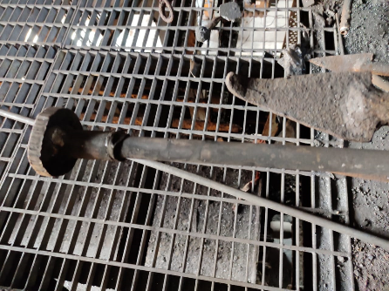 Dolly used for plugging the tuyere with hydrous clay

**Procedure:**

1. Unauthorized operation or repair of any equipment is a punishable offence.
2. Whenever shutdown is to be taken, ensure furnace is hot/normal condition, Unless and until required for emergency for which instructions is to be taken from GM/ Manager Production.
3. Before opening the cast inform -service departments, PCI in-charge, HOD’S & GEL regarding the furnace shutdown
4. Stop batching of raw material in advance as per the planned shutdown timings. Empty all weighing bins incase weighing bins calibration is to be done
5. Top gas temperature to be control around 250 deg cent by judiciously dumping and by using top water spray.
6. Ensure steam in between the bells,
7. Stop Pulverized coal injection (If running) 1 hour before the shutdown. Take all lances on Nitrogen.
8. Open the cast. As the cast starts blowing reduce wind volume gradually to 15000 Nm3/hr (0.50 Kg/cm2 pressure). Blow the furnace for 5 min. so that all the metal and slag is drained out and close the cast.
9. After cast closes, ensure that all PCI lances have been taken out and flushed. Ensure person caring out the activity wear proper PPE’s viz safety over coat, safety helmet with screen, safety shoes and hand gloves.
10. Open and blow the dust catcher to remove all dust. (Preferably when IVC is full closed)
11. Ensure last dump to be coke incase top firing is to be done with top gas temperature above 300 deg. cent.
12. Inform GEL regarding the gas availability and shutdown
13. Ensure gas flow to GEL is continuous/ uninterrupted from the other running furnace.
14. Ensure that furnace is not hanging before taking shutdown. If hanging give a forced check and ensure the furnace has slipped before taking shutdown.
15. Inform GEL to charge the steam header so as to get 7 kg/cm2 pressure
16. Reduce wind volume to 6000 Nm3/hrs. (0.30 Kg/cm2 pressure) by opening snort valve and keep 2 blowers on run.
17. Open steam in uptakes, dust catcher and saturator.
18. Put venturi-2 in manual mode and open both the venturies fully
19. Open relief valve and close the equalizing valve
20. Ensure that EV-1 is disabled by removing the fuses. Keep the permit in custody of control room Engineer.
21. Start water sealing the saturator and main gas line, as the blast pressure starts increasing open one bleeder. This should be the electrical winch bleeder which is operated by control room engineer in coordination with cast house engineer. Healthiness of electrical bleeder winch to be ensured prior to shut down. Has to be kept engaged.
22. Ensure gas flow to GEL is continuous/uninterrupted from the other running furnace. Mainline water sealing valve wheel to be lockout with lock out pad after water sealing and ensure slight continuous overflow of water from the seal. Ensure that additional water seal is also water sealed and lock out pad to be used. Both water sealed is must during shutdown.
23. Ensure two CO monitor is used while water sealing gas lines.
24. After the saturator gets water sealed open second bleeder
25. Water seal the furnace#1 isolation seal (new) main gas line. Water sealing valve wheel to be lockout with lock out pad after water sealing and ensure slight continuous overflow of water from the seal.
26. Common water seal of all three stove gas lines. Water sealing valve wheel to be lock out with lock out pad after water sealing and ensure slight continuous overflow of water from the seal.

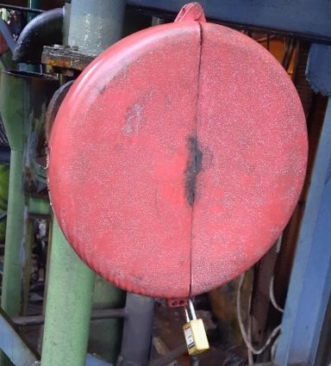

1. Box-up the other two stoves which are not on blast and stop ID and CA fan
2. Reduce the furnace pressure gradually to 0.05 Kg/cm2
3. Open two peephole flange, ensure no person is standing in front of the blowpipes, to avoid burn injuries due to flying hot debris or hot coke from inside the furnace.
4. Don’t allow any person to pass in front of the blowpipes whose peephole flanges are kept open till back draught of the furnaces.
5. Ensure that the curtain of cerewool cloth in front of tuyere is lowered before taking shutdown.
6. Back draught the furnace after opening two peep-hole flanges and removing all the people from in front of the blow pipes to avoid gas poisoning and burn injuries in case of backfire.
7. Select back draught mode
8. Put stove in SEMI AUTO MODE
9. Isolate ON BLAST stove to ISOLATION STAGE
10. Close MMSV valve
11. Close furnace isolation valve
12. Go to any stove & open coffee pot latch
13. Open cap
14. Whenever there is instruction for backflushing, backflushing to be done as per procedure mentioned in respective WI. (In case Back - flushing of stoves is planned, ensure all 4 blowers are running. After top firing, back flushing of stoves to be done as planned. Then blowers can be stopped).
15. Stop 3 blowers after back draught and keep one blower running till top firing
16. Open all peephole flanges
17. Check all tuyeres and tuyere coolers for water leakage by inserting a cold & dry rod inside the blowpipe and checking for dampness or by blowing slight compress air.
18. Persons carrying out the tuyere checking/plugging activity should wear safety screen helmet, hand gloves, safety shoes, as furnace may slip creating backfire or hot coke thrown out from the blowpipe.
19. Care to be taken that the damp or hot rod is not used for checking tuyere water leakage.
20. Plug all tuyeres with hydrous clay and give clearance for top firing. Ensure no body is within the vicinity of the plugged tuyeres till the time top firing is complete.
21. For top firing ensure permit is taken and two co monitor are used, minimum two person has to go for top firing (one should be senior most person of the shift).Top hatch to be opened with the help of lancing hook by standing one mtr away from manhole to avoid burn injury due to sudden ignition of gas and auto slip of furnace After top firing is observed wire mesh which is provided is to be placed on opened flange and secured with wedge pin.
22. After top firing stop last blower, open dust catcher bell and sliding gate, stop steam in between bell, uptake dust catcher. Stop CA fan and ID.
23. Steam purge gas line by opening relief valve one by one.
24. Ensure only two tuyeres peephole flanges are kept open where people movement is less preferably tuyere no.1 and 8 and others to be loosely closed.
25. After saturator is water sealed, stop the GCS and venturi pumps.
26. Keep the flare stack actuator valve closed in manual mode after water sealing the flare stack main water seal, additional water seal to GEL. All Water sealing valve wheel to be lockout with lock out pad after water sealing and ensure slight continuous overflow of water from the seal.
27. Stop furnace stack shell cooling water half an hour and bosh cooling one hour after reducing wind volume to zero and keep all water sprays on for tuyere, tuyere coolers, cooling plates & below the tuyere /tap hole level.
28. Do not stop or reduce the water of tuyeres, tuyere coolers and copper cooling plates in the bosh region if shutdown for short duration. However, if the S/D is of more than 3hours reduce water in copper cooling plates such that delta T (temp. difference between outlet & iinlet) is maintained same as in running furnace i.e., 2~3 deg cent and keep monitoring the outlet water temperature and outlet flow of cooling plates. All individual cooling plate inlet water valves are to be made free.
29. Open and replug all the tuyeres one by one after 01-02 hour of shutdown for rechecking of water leakage also ensure that no body is working on bleeders, bells and other confined areas at furnace top such as charging hopper.
30. Barrication of area needs to be done where the fall of material is involved and should be carried out under supervision

|  |  |  |
| --- | --- | --- |
| **Prepared By:**  Head – Production PID I | **Reviewed & Issued By:**  Management Representative | **Approved By:**  Head – Pig Iron Division |
| **Signature:** | **Signature:** | **Signature:** |
| **Date: 15.07.2022** | **Date: : 15.07.2022** | **Date: : 15.07.2022** |

|  |  |  |  |
| --- | --- | --- | --- |
| **Amendment Record** | | | |
| **Revision date** | **Manual Section ref. and para** | **Brief details of revision** | **New Revision No.** |
| 12.07.2021 | **Procedure for Shutdown of blast furnace - I** | Point no 9,21,40 | 15 |
| 15.07.2022 | Procedure for shutdown of blast furnace I | Point 26 | 16 |